Name – Akshat Bhargava

Roll no – 22563

DS – SL3

Prac 5

Code:

1. Import libraries, load and process ‘Social_Network_Ads.csv’ dataset.

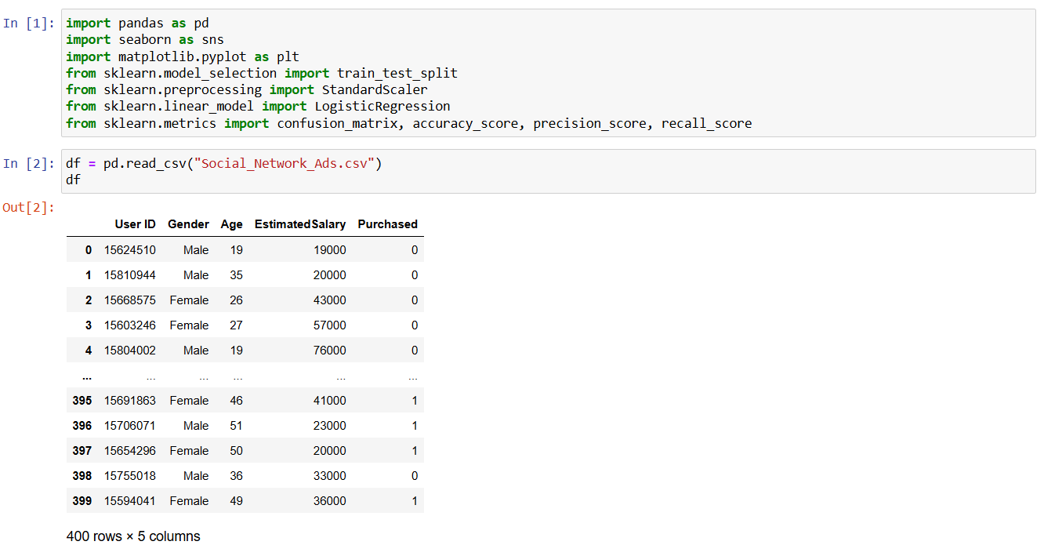

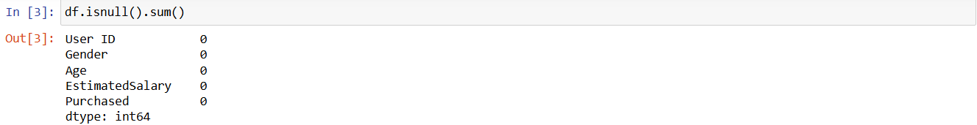

2. Implement logistic regression using Python/R to perform classification on Social_Network_Ads .csv dataset.

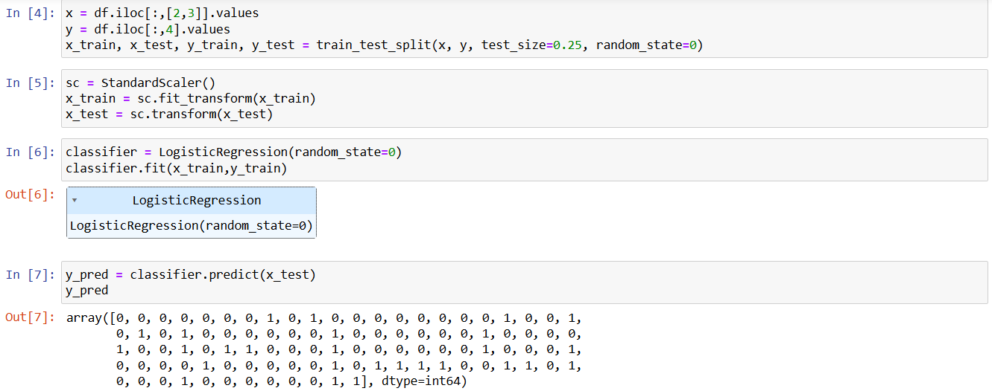

3. Compute Confusion matrix to find TP, FP, TN, FN, Accuracy, Error rate, Precision, Recall

on the given dataset.

